Installing the Blackberry v4.0 Software
- Make sure that the Blackberry Desktop Manager (if previously installed on your system) is not running. If it is, it will be located in your System Tray in the lower right hand corner of your screen and will be shaped like a small Blackberry icon as shown below.
Note: You only need to do step 1 and 2 if you have had a Blackberry previously. If you are installing a Blackberry for the first time, go immediately to step 3.
- Close the Blackberry software (if it was found running in the previous step) by double clicking on the Blackberry icon located in your system tray, click on the File menu and then select Exit.
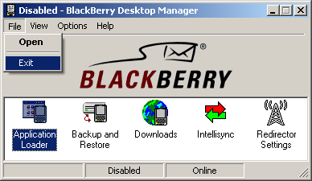

- To run the software, please locate and double click on BlackBerry_Desktop_Software_v4.0.exe that you can download from the Blackberry intranet page.
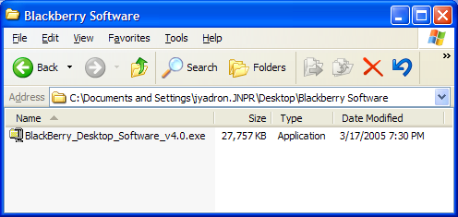

- Click the Next button at the InstallShield Wizard welcome screen.
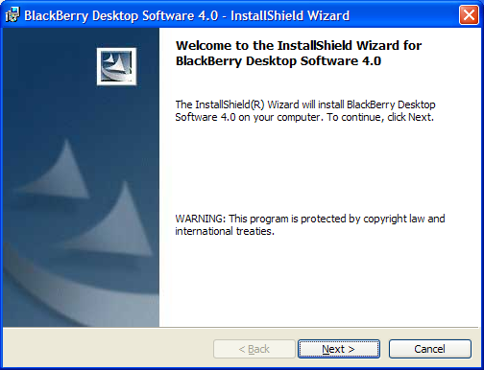
- By default, USA should already be selected. Click Next.
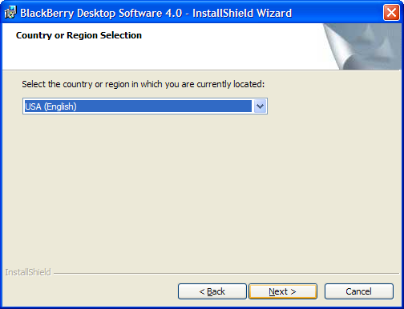
- Select Yes to proceed.
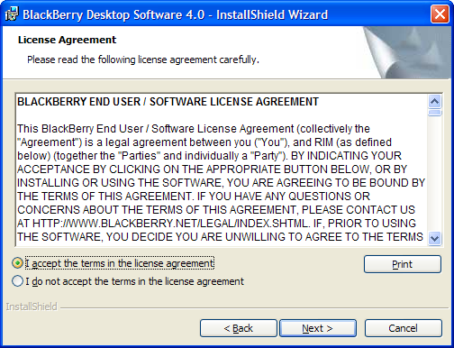
- Type in your user name and click Next.
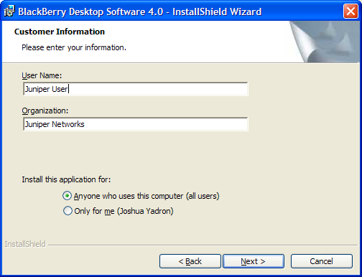

- The Installation Wizard should automatically install the Blackberry Desktop Manager in the correct location. Click Next to proceed.
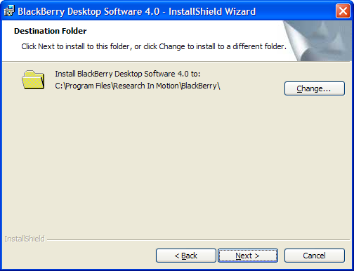

- Make sure that “Typical” is selected and click Next.
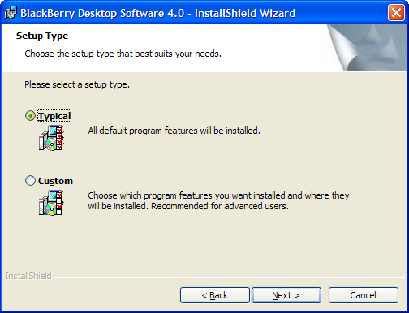

- Make sure “BlackBerry Enterprise Server or BlackBerry Desktop Redirector” is selected and click Next.
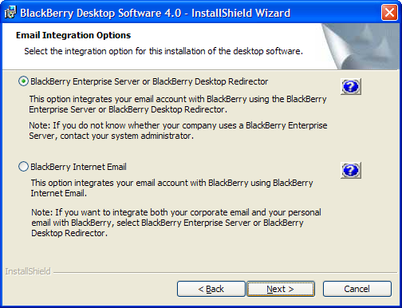

- Make sure “Microsoft Exchange (typically used with Microsoft Outlook client)” is selected and click Next.
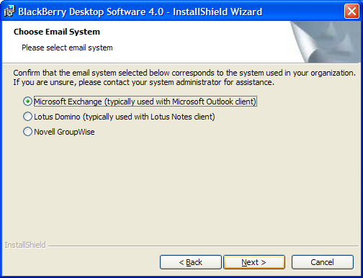

- Select “Redirect email using the BlackBerry Enterprise Server” and click Next.
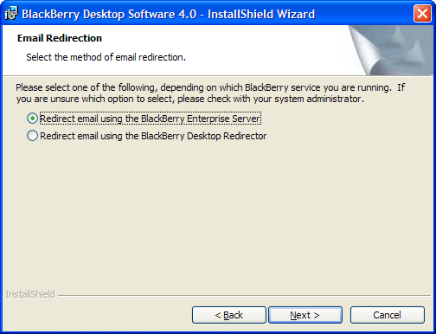

- If the first box is checked, the Blackberry Desktop Manager will start each time your Windows laptop is booted.
Note: If you are not on the Juniper corporate network and must use VPN software to connect, you will want to uncheck the first box and manually start the application whenever you wish to sync.
If the second box is checked, the Blackberry Desktop Manager will have a shortcut on your desktop making it easier to quickly launch the application.
Click Next to proceed.
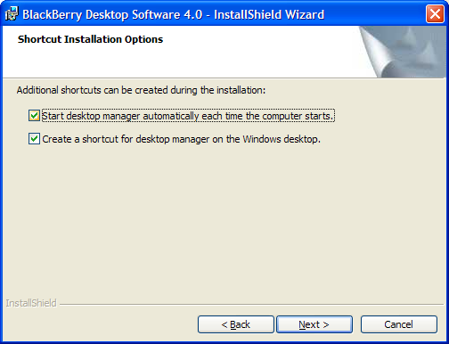

- Click Install.
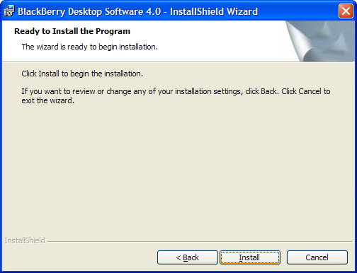

- Uncheck both boxes, and click Finish to complete the installation.
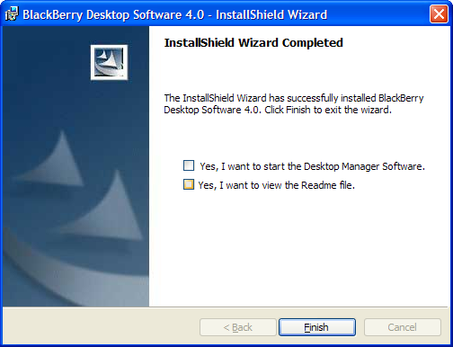
- Please reboot your computer for installation to complete.

