Configuration of the Blackberry Desktop Manager v3.6 software
- Make sure that the Blackberry Desktop Manager is not running. If it is, it will be located in your System Tray in the lower right hand corner of your screen and will be shaped like a small Blackberry icon as shown below.
- Close the Blackberry software (if it was found running in the previous step) by double clicking on the Blackberry icon located in your system tray, click on the File menu and then select Exit.
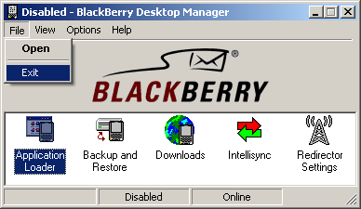

- Plug your USB cradle into the back of your computer, and then plug your Blackberry into the USB cradle. The Windows “Found New Hardware Wizard” will appear on your screen. Choose Install the software automatically (Recommended) and click Next to continue.
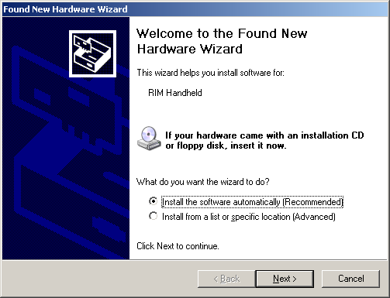
- The driver for the Blackberry will begin to install automatically. [Note to Windows XP users: An additional screen may pop up during the install asking to confirm the installation, click Continue Anyway.]
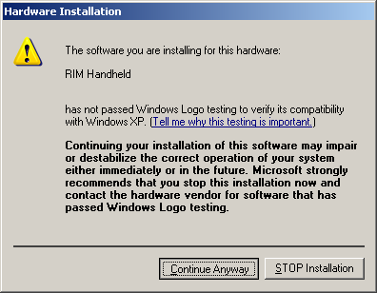

- Your Blackberry software will now be finished installing. Click Finish and Unplug the Blackberry from the USB cable.
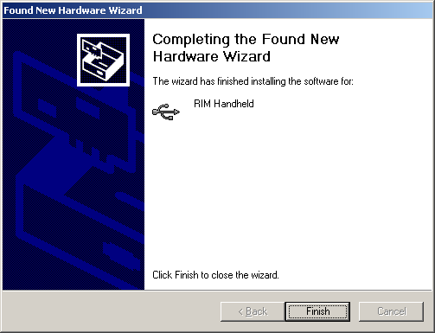
- Open the Blackberry Desktop Manager and double-click on the Intellisync icon.
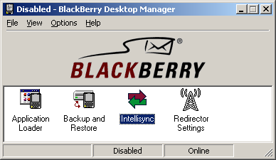

- Click Auto Start…
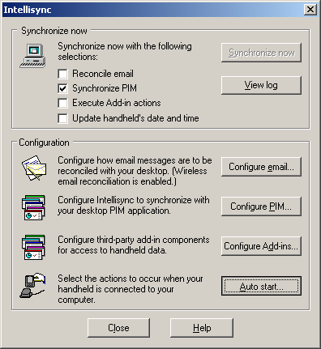
- Make sure that Update handheld’s date and time is the only box that is checked and that the other three are unchecked. Then click OK, followed by Close to return to the main Blackberry Desktop Manager screen.
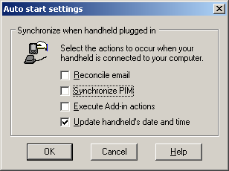

- In the Blackberry Desktop Manager click on the Options menu.
- Select Hide When Minimized. Click on the Options menu and open Connection Settings.
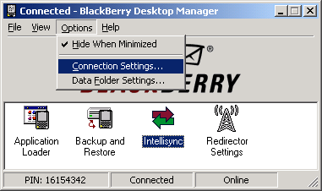

- Select the Connection drop-down menu and choose USB and click OK.
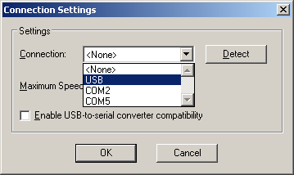

- Please re-connect your Blackberry to the USB cable and you will be asked if you would like to switch to the currently connect handheld, choose Yes.
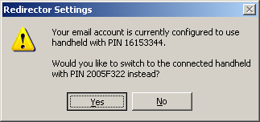
- Click OK
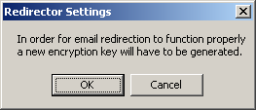
- Move your mouse along the screen to generate a new encryption key.
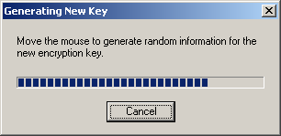
- At this point your Blackberry will communicate with the software for the first time, it may take a few moments again before you can resume. You may also be prompted for a password on the Blackberry screen. Just follow the on-screen directions.

- Double-click on the Intellisync icon.
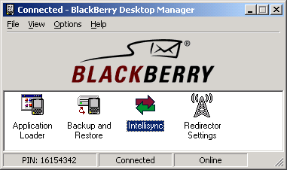

- Click Configure PIM…
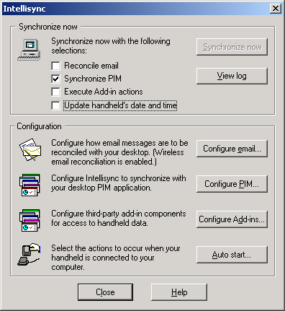

- For the PIM (Personal Information Manager) options, only one default option needs to be changed. Highlight Calendar and click the Choose button on the right.
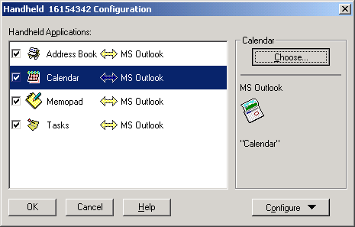

- Scroll Available Translators list to the top and select BlackBerry Wireless Sync. Click OK.
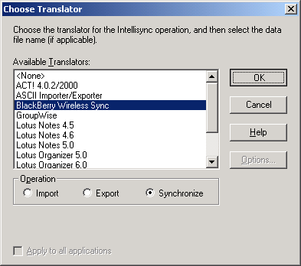

- Your PIM options should now look similar to the screenshot below. If this is true, click OK.
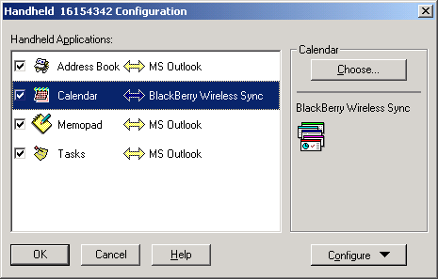

- Click Auto Start…
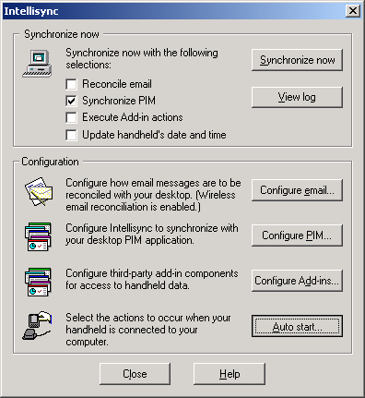

- Check the boxes for Reconcile Email and Synchronize PIM and then click OK.
Note: These are the check boxes found within the Auto start… area. They are not the check boxes at the top of the Intellisync options window shown in step 8.
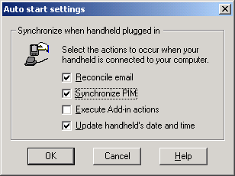

- It is now safe to close the Intellisync options window by clicking on Close.
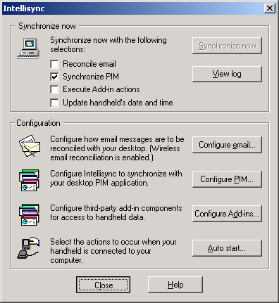

Your Blackberry software is now configured to automatically detect your Blackberry when it is plugged into the USB cable and synchronize your contacts, calendar, tasks and memos all from Microsoft Outlook. This will happen every time you connect with the USB cable.
Note: If your Blackberry handheld has a password on it, the Synchronization process does not automatically begin unless the password has been entered into the device.

