Installing the Blackberry v3.6 Software
- Make sure that the Blackberry Desktop Manager (if previously installed on your system) is not running. If it is, it will be located in your System Tray in the lower right hand corner of your screen and will be shaped like a small Blackberry icon as shown below.
Note: You only need to do step 1 and 2 if you have had a Blackberry previously. If you are installing a Blackberry for the first time, go immediately to step 3.

- Close the Blackberry software (if it was found running in the previous step) by double clicking on the Blackberry icon located in your system tray, click on the File menu and then select Exit.
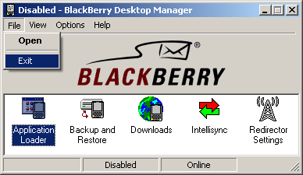

- The software should run automatically when inserted into the CD-ROM. If it fails to do this, go to My Computer, Double click on DK3.6.0_54.
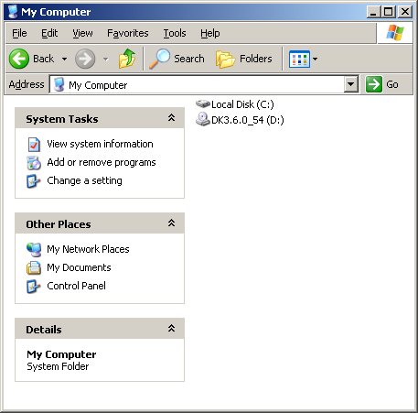

- Click the Next button at the InstallShield Wizard welcome screen.
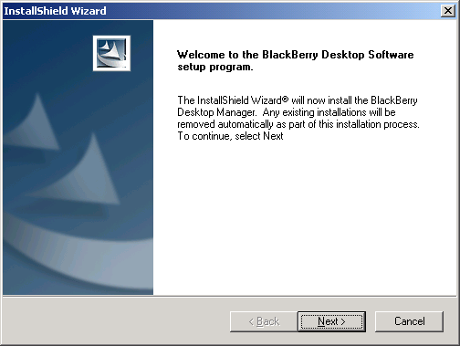

- By default, USA should already be selected. Click Next.
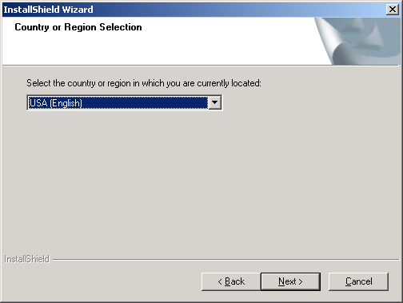
- Select Yes to proceed.
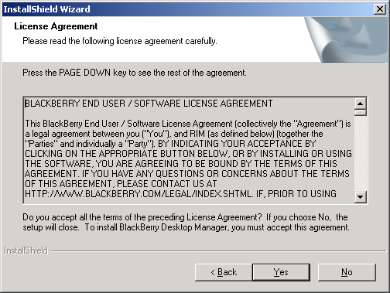
- Type in your user name and click Next.
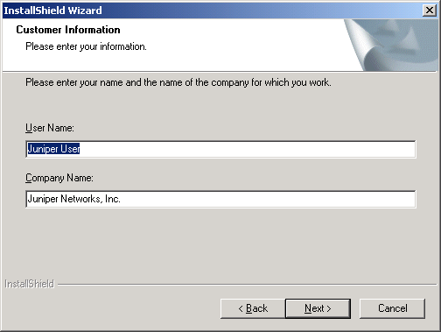

- Make sure “Integrate with enterprise email account” is selected and click Next.
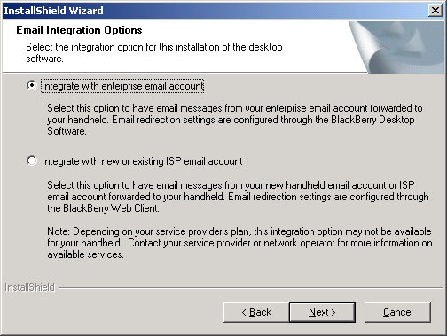

- Make sure “Microsoft Exchange (typically used with Microsoft Outlook client)” is selected and click Next.
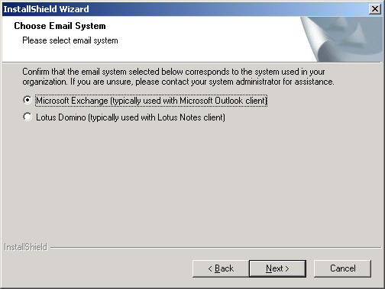

- Select “Redirect email using the BlackBerry Enterprise Server” and click Next.
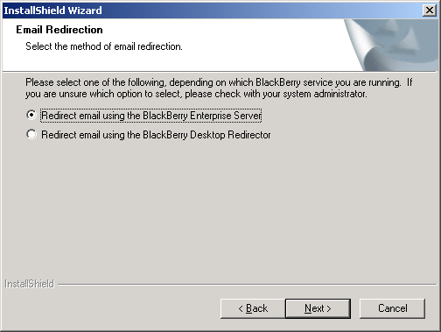
- Click Next.
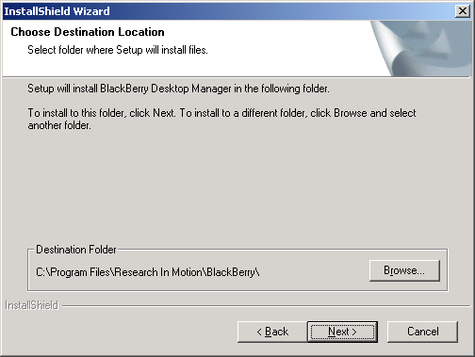

- Click Next.
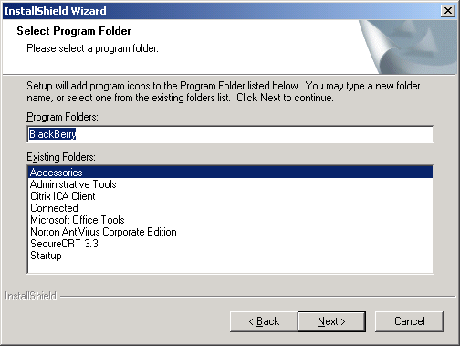

- Click Next.
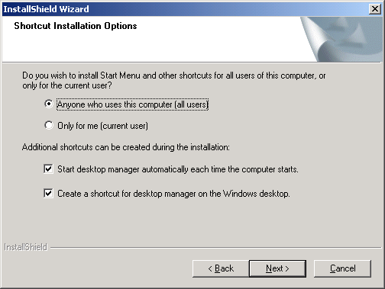
- Installation will begin now. [Windows XP users only: Windows XP will have an alert window pop up asking you to verify installation. Click Continue Anyway]
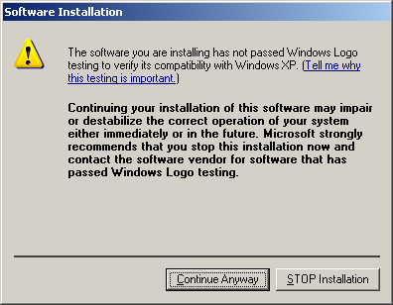

- Uncheck both boxes, and click Finish to complete the installation.
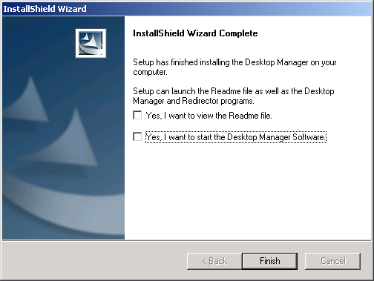
- Please reboot your computer for installation to complete.

